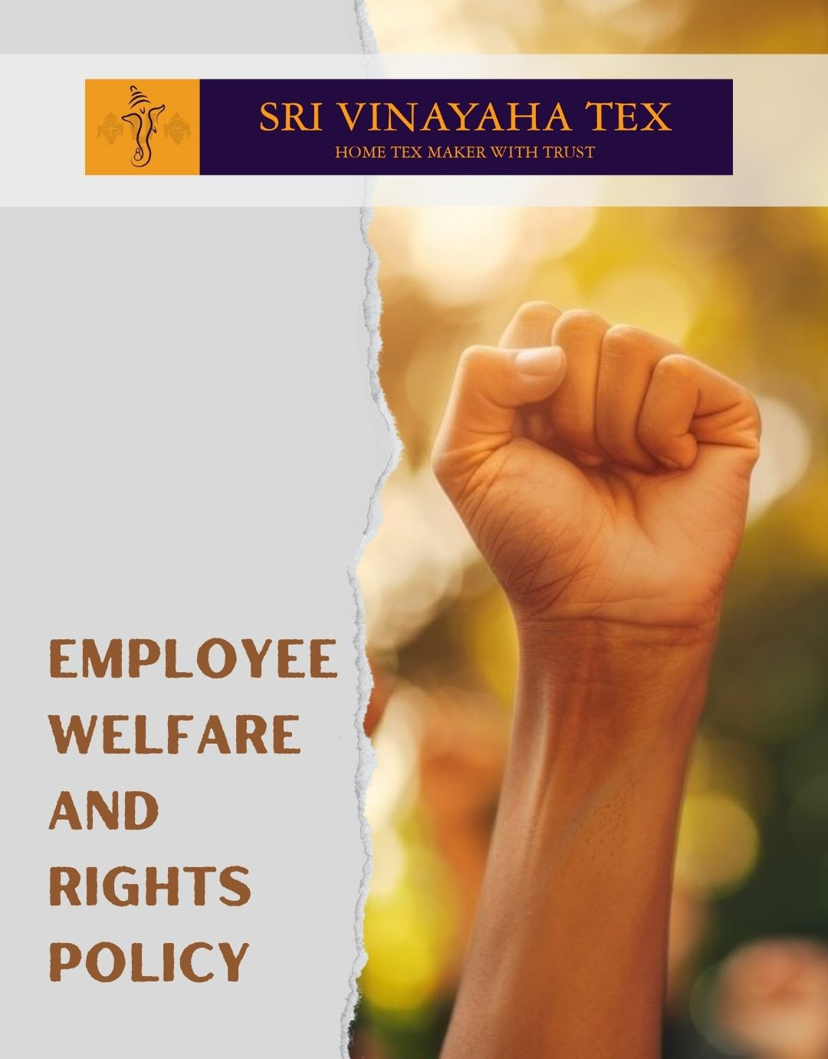

TABLE OF CONTENTS
PROLOGUE 2
SCOPE 2
POLICY DECLARATION 2
INITIATIVES AND TARGETS IN ALIGNMENT WITH SDGs 3
PERFORMANCE REPORTING 4
REVIEW MECHANISM 5

PROLOGUE

As a prominent global supplier and exporter of Indian Home Textile Products, Sri Vinayaha Tex is unwavering in its commitment to upholding the highest standards of employee welfare and rights. Our products are manufactured using ethical and responsible practices. This policy outlines our dedication to fostering a safe, equitable, and inclusive workplace, addressing critical aspects such as employee health and safety, fair compensation and benefits, working conditions, labor relations, career development, prevention of child and forced labor, diversity, equity and inclusion, protection of external stakeholder human rights, and promoting work-life balance.

SCOPE

This Policy is applicable to following sites and all of its employees, workers, sub-contractors and other stakeholders:

Sr. No. | Site | Address
1 | SHRI VINAYAHA TEX
2 | SHRI VINAYAHA TEX

POLICY DECLARATION

Sri Vinayaha Tex pledges to maintain and enhance the well-being of our employees through rigorous adherence to international labor standards and best practices. We are dedicated to fostering a work environment where every employee is valued, respected, and given the opportunity to thrive. Our baseline year is 2023, which will serve as the reference framework for assessing progress and compliance in our employee rights and welfare practices.

INITIATIVES AND TARGETS IN ALIGNMENT WITH SDGs
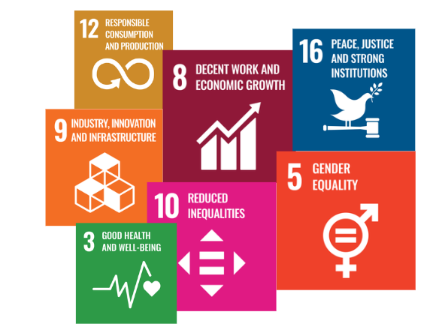

- Develop and maintain robust safety protocols and emergency response plans.
- Achieve a 100% compliance rate with safety regulations by year 2030.
- Provide comprehensive benefits packages tailored to employee needs and ensure transparent salary structures
- Implement regular maintenance and improvement programs for workplace conditions
- Conduct quarterly inspections with zero non-compliance issues related to working conditions
- Maintain a 95% adherence rate to established workplace safety and comfort standards by year 2030.
- Promote a culture of mutual respect and collaboration between management and staff.
- Establish effective channels for employee feedback and grievance resolution.
- Resolve 95% of employee grievances within 30 days of receipt through structured processes.
- Offer regular training and development opportunities to support career progression.
- Ensure that 85% of employees have access to career development programs annually, with at least 75% participating by year 2030.
- Enforce strict policies against child and forced labour, ensuring all suppliers adhere to these standards.
- Conduct annual audits of 100% of our supply chain to confirm compliance with child and forced labour regulations by year 2030.
- Promote a diverse and inclusive workplace where all employees feel respected and valued.
- Achieve a 25% increase in diverse representation at all levels of the organization by year 2030
- Engage with external stakeholders to support and promote human rights initiatives.
- Review and address any human rights concerns raised by stakeholders within 60 days of notification.
- Provide flexible working arrangements and support employees in balancing their work and personal lives.
- Achieve a 90% or higher employee satisfaction rating related to work-life balance in annual surveys by year 2030.

PERFORMANCE REPORTING

Sri Vinayaha Tex will provide annual reports detailing progress towards the above targets. These reports will include qualitative assessments, quantitative data, and an overview of any corrective actions taken. Reports will be made available to all employees and stakeholders to ensure transparency and accountability.

REVIEW MECHANISM

This Employee welfare and rights policy will be reviewed annually by the HR manager to ensure its relevance and effectiveness. Feedback from employees, changes in legislation, and advancements in best practices will inform any necessary revisions. The review process will involve consultations with key stakeholders, including employee representatives and external auditors, to ensure comprehensive and ongoing improvement in our employee welfare and rights practices.

REV. No. 01

EFFECTIVE FROM: 01.01.2024 NEXT REVIEW DATE: 01.01.2025
APPROVED BY: PRESIDENT - OPERATIONS

